Faculty of Computing



**Operating Systems**

**Fall 2025**

**LAB # 02**

## Instructor

Ayesha Akram

Faculty of Computing,

Riphah International University, Islamabad

# Linux Installation:

In the previous Lab there was a brief introduction about Operating System and Linux. Objectives of today's lab is to learn how to install Linux **(Ubuntu)** and setting up environment and some basic Linux commands.

## Basic Terminologies:

When Operating system is power on, it loads operating system files into RAM. This process is called **boot** a system. Program that perform this job is called **boot-loader.**

Different Ways to run multiple operating systems on the same machine are given below:

#### Dual-boot:

* + One of the most common ways to achieve multiple usable operating systems on a single computer is known as dual boot.
  + It allows you to select an operating system during startup.

#### 

* + You can use only single Operating System at one time i.e. computer must be restarted whenever the user wants to switch to the other operating system. The advantage of dual boot is each operating system works practically independent of the other.

#### Virtualization:

* + Virtualization is a newer way of running multiple operating systems on one system. Virtualization requires a virtualization program such as Oracle's [VirtualBox](https://www.virtualbox.org/) [(](https://www.virtualbox.org/)$0) or VMWare's [VMWare](http://www.vmware.com/products/workstation/index.html) [Workstation](http://www.vmware.com/products/workstation/index.html) [(](http://www.vmware.com/products/workstation/index.html)~$200)
  + The virtualization program is installed on your host or primary operating system, and then your 'guest' operating systems are installed within that application.
  + The main advantage of virtualization over dual boot is that you are able to run both of your operating systems simultaneously without rebooting.

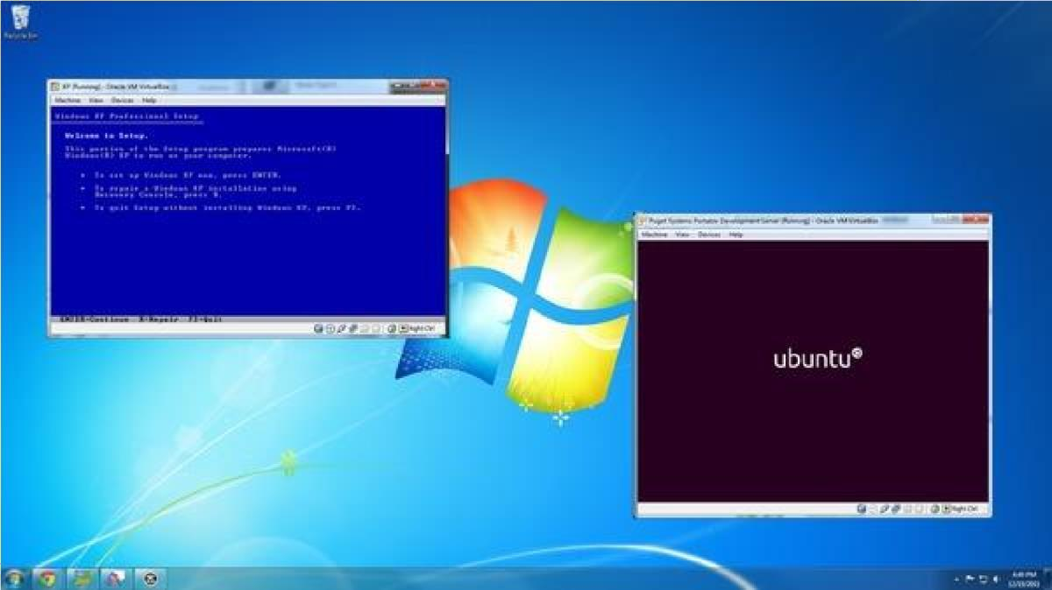

* + The most obvious drawback of virtualization is that if your host OS is not working right, your guest operating systems could be affected by those problems.
  + System hardware needs to support virtualization. This feature can be disabled and enabled. Normally older systems don't support virtualization. So first turn on virtualization setting from BIOS.

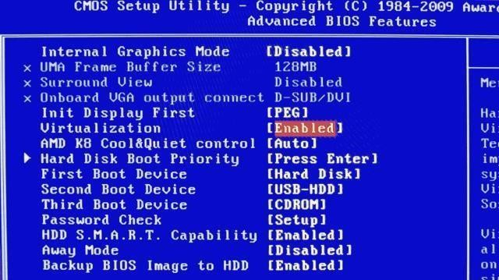

## VMware

VMware, Inc. is a company providing virtualization software, founded in 1998 and based in Palo Alto, California, USA. VMware's desktop software runs on Microsoft Windows, Linux, and Mac OS X.

## Desktop software

* VMware Workstation (first product launched by VMware in 1999) is a virtualization software. This software suite allows users to run multiple operating systems on a single physical PC.
* VMware Fusion provides similar functionality for users of the Intel Mac platform, along with full compatibility with virtual machines created by other VMware products.

## Linux (Ubuntu) Installation:

To install Linux you need to have VMWare/Virtual Box, and Ubuntu ISO Image file.

* **VMware** already installed (if not installed inform to Lab staff)
* **ISO Image** for Ubuntu Linux is placed in **D:\software** in every system of Lab.

## Organization of the Linux File System

Unlike DOS, which permits you to organize your disks any way, the Linux file system is organized into a standard directory structure. A portion of the Linux directory structure is pictured below:

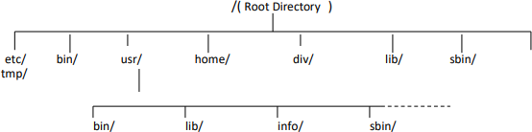

#### Root Directory

The top most directory is called root directory. The hierarchical structure of directory begins with a root directory. The name of root directory is /.

#### Directory

A file, which holds other files and sub-directories.

#### Subdirectory

A directory residing within another directory.

#### Home Directory

The directory selected by Linux as the working directory when a user logs on. When a user logs on Linux selects **home directory** (its name usually matches your login name) as his/her **working directory**.

**Current/Working Directory**

The directory currently being used.

#### Pathname

Pathname is a reference to identify a file within the directory structure. For example the following file name indicates the file in the hierarchy of directories:

#### /usr/users/bill/letters/pay

The first slash (/) indicates the root directory (start from root directory), move down to **usr**, then **users**, then **bill**, then **letters** and finally to the **file**. So this pathname is reference to the file **pay** with respect to the root directory.

A path may be of two types.

### Absolute Pathname

The pathname, which identifies a file or a directory irrespective of the current state of the user. The user's "current directory" is part of the user's state. The absolute pathname always starts from the root directory.

For example, to locate file any file in **lib** directory, the absolute path of the file is:

**/usr/local/lib/filename**

### Relative pathname

The pathname, which identifies a file or a directory in a way that depends on the state of the user i.e. users current directory. Relative pathname identifies files with respect to user’s current directory.

**Tasks:**

1. What is the advantage of virtualization over dual boot?
2. What is the difference between a directory and a subdirectory?
3. Why does the relative path depend on the current directory?
4. Why does the absolute path always start with /?
5. How is the home directory different from the root directory?